

Group#1

Okaz Library
Software Design Specification (SDS)
Version: 2.0
CM Identifier: G1_SE_SDS_Itr1_v1.0

Revision History

Sl. No. | Prepared/  Modified by | E-mail | Version | Date | Approved by | Descriptions/  Remarks
1. | Mohamed Mayla | mohamed.mayla @gmail.com | V1.0 | April 15,2013 | N/A | Design Models
2. | Eslam Hashem | eslam.hashem7 @gmail.com | V1.0 | April 16,2013 | Mohamed Mayla | Data Models and System Deployment
3. | Nada Karam | nada_karam23 @yahoo.com | V1.0 | April 16,2013 | Mohamed Mayla | Introduction
4. | Hagar Bedr | hagar.bedr @yahoo.com | V1.0 | April 17,2013 | Mohamed Mayla | System Architecture and Traceability to Requirements
5. | Mohamed Mayla | mohamed.mayla @gmail.com | V2.0 | MAY  10,2013 | N/A | Class diagrams
6. | Mohamed Mayla | mohamed.mayla @gmail.com | V2.0 | MAY  11,2013 | N/A | Sequence diagrams
7. | Hagar Bedr | hagar.bedr @yahoo.com | V2.0 | MAY  12,2013 | Mohamed Mayla | Traceability to Requirements
8. | Nada Karam | nada_karam23 @yahoo.com | V2.0 | MAY  14,2013 | Mohamed Mayla | Checking all

Distribution list
Name | E-mail | Notes
Dr. Sayed Hemayed | hemayed@ieee.org | For approval
Eng. Omar Khaled | eng.oks@gmail.com | For approval

Table of Contents

1. Introduction 9
1.1 Purpose of this Document 9
1.2 Scope 9
1.3 Table of Acronyms and Definitions 10
1.4 References 10
1.5 Overview of Document 10
2. System Architecture 11
3. Design Models 12
3.1 Web pages design 12
3.1.1 Home page 12
3.1.2 Book list 13
3.1.3 Uploading page 14
3.1.4 About us 15
3.1.5 Contact us 16
3.1.6 Log in (Admins & Managers) 17
3.1.7 Manage page 18
3.1.8 Information page 19
3.1.9 Admin lists 21
3.1.10 Message page 22
3.2 Class Diagrams 23
3.2.1 CD1 23
3.2.2 CD2 24
3.2.3 CD3 25
3.2.4 CD4 26
3.2.5 CD5 27
3.2.6 CD6 28
3.2.7 CD7 29
3.2.8 CD8 30
3.2.9 CD9 31
3.3 Interaction Diagrams 32
3.3.1 SD1 32
3.3.2 SD2 33
3.3.3 SD3 34
3.3.4 SD4 35
3.3.5 SD5 36
3.3.6 SD6 37
3.3.7 SD7 38
4. Data Models 39
5. System Deployment 40
6. Traceability to Requirements 41

List of Tables

Acronyms and Definitions 7
Traceability to requirements 13

List of Figures

Figure 1 : System Architecture 10
Figure 2 : Home page showing slide show 11
Figure 3 : Home page footer 11
Figure 4 : book list 12
Figure 5 : uploading page 13
Figure 6 : about us page 14
Figure 7: contact us page 15
Figure 8: login 16
Figure 9: login data entered 16
Figure 10: manage 17
Figure 11: manage data entered 17
Figure 12: information page - current request 18
Figure 13: information page - history 18
Figure 14: information page - current borrower 19
Figure 15: Admin list - manager version 20
Figure 16: Admin list - admin version 20
Figure 17: Message page 21
Figure 18 22
Figure 19 23
Figure 20 24
Figure 21 25
Figure 22 26
Figure 23 27
Figure 24 28

Introduction
This SDS is for Okaz Library, which is a website for Okaz activity on Cairo University to let them easily manage the book shared with peoples (students)^{[4]}.

Purpose of this Document
The purpose of this SDS is to give all the information needed about the design of Okaz library website such as the class diagrams, the sequence diagrams and the description for each, as the basic idea of the project is to manage sharing books between students and make it easy to be managed with Okaz library managers (activity).
The website provide users (students) who want to loan a book to the library, easily upload the book cover (to make sure he has the book) with his name and phone number, after that he/her should deliver the book to the library managers, after that the book will appear on the website that is available to borrow.
The users (students) who want to borrow a book, should send request to borrow selected book from the website with his/her name and phone number, and then go the receive the book from the library for a certain time.
The manager of the Okaz library will manage all the above activities^{[4]}.

Scope
The scope of this SDS was discussed thoroughly by the team members developing this website with Okaz library activity managers. It’s was agreed upon that in the version 1.0 will have the full functionality of the website.
The system will provide the “smart confirmation code” feature that let managing all the activity by the managers more easy and fast, and the system will save the data on an online server.
The website will be ready to be published on the internet and ready to be used by the users.
The application will support simple use cases such as upload cover book, borrow a book and request confirmation by the managers with some complex use cases such as the generation of the “smart confirmation code” , the admin activity like delete a book^{[4]}.

Table of Acronyms and Definitions

Term | Definition
ASP.net | server-side Web application framework
HTML | Hyper Text Markup Language
HTTP | Hypertext Transfer Protocol
HTTPs | Hypertext Transfer Protocol Secure
IP | Internet Protocol
SDS | Software Design Specifications
SRS | Software Requirements Specifications

table 1 – Acronyms and definitions

References
- Software Engineering Course Lecture Notes, Dr. El Sayed Hemayed.
- www.asp.net
- http://www.w3schools.com
- The Software Requirements Specifications document (SRS).
- http://code.google.com/p/software-engineering-project-cufe-2015-group1
- www.facebook.com
- http://www.agilemodeling.com/artifacts

Overview of Document
The rest of this document is going to specify the system architecture and the subsystems of the project in a way that will be very easy to understand, it will also describe the different subsystems of the project and the classes of each subsystem, also it will thoroughly describe the sequence diagram of every use case of the project, along with the ERD and the Relational modeling of the database.

System Architecture
The system of this project is going to be decomposed into three subsystems, or layers;
- The User Application Layer.
- The Web Service Layer.
- The Database Layer.
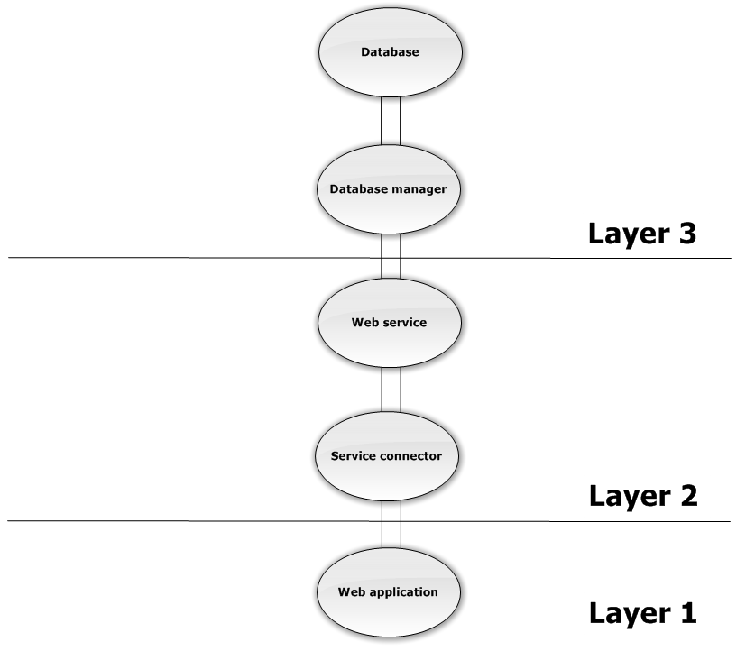
Each layer has its own classes and methods of interacting with other layers, so the structural model we are going to use here is the layered model; the following figure shows the system architecture and its layers.
Figure 1 : System Architecture

Design Models

Web pages design

Home page

Figure 2 : Home page showing slide show

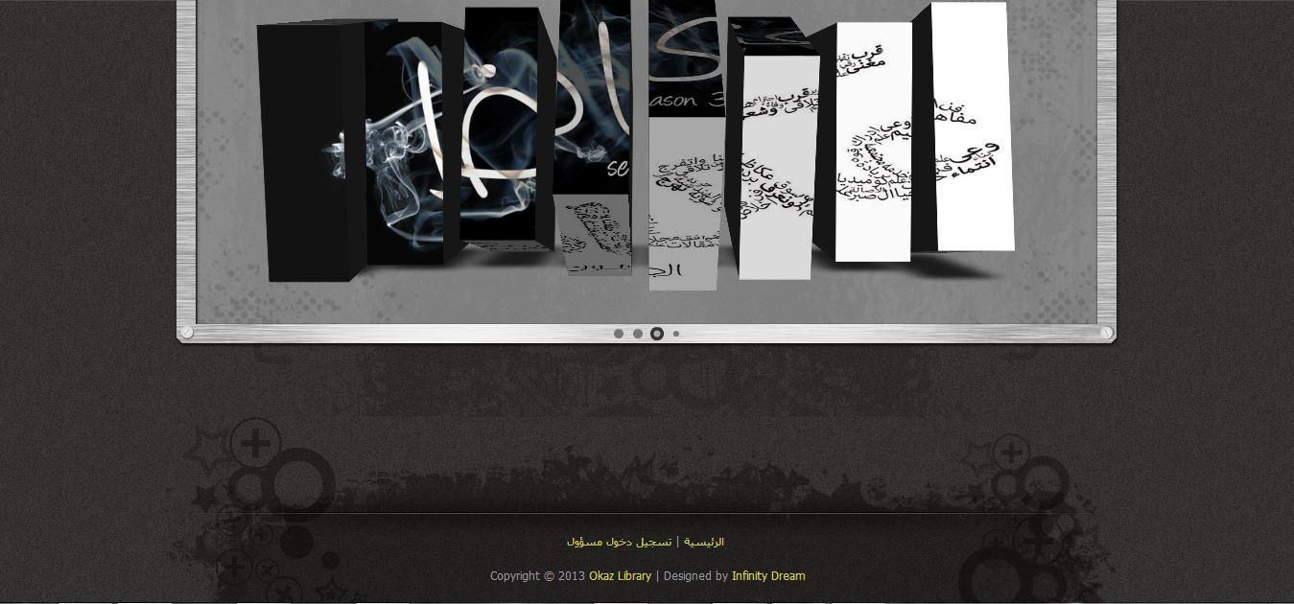
Figure 3 : Home page footer

Book list

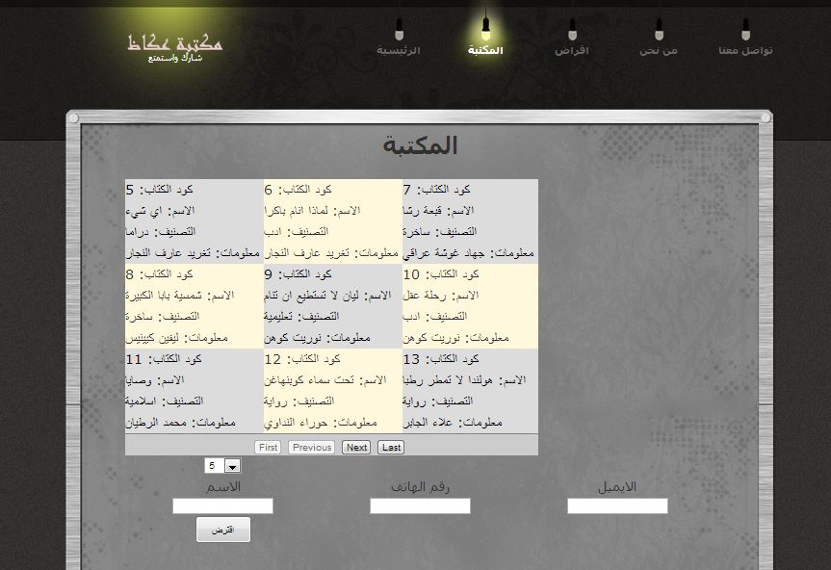
Figure 4 : book list

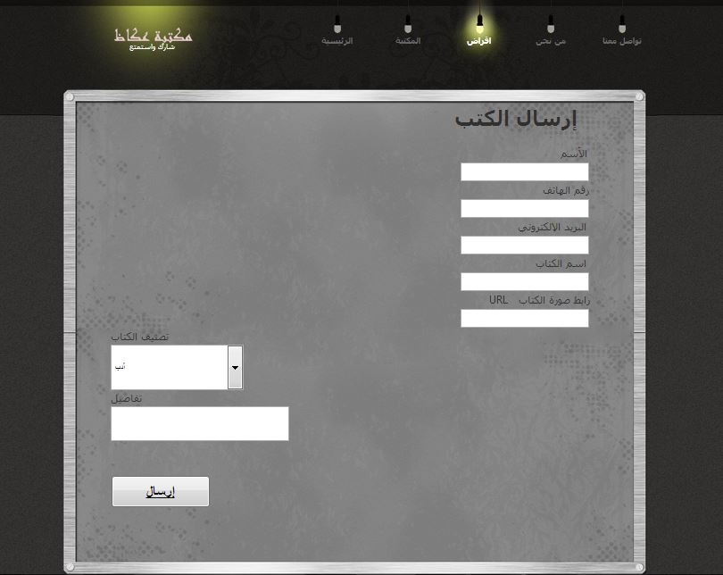
Uploading page
Figure 5 : uploading page

About us
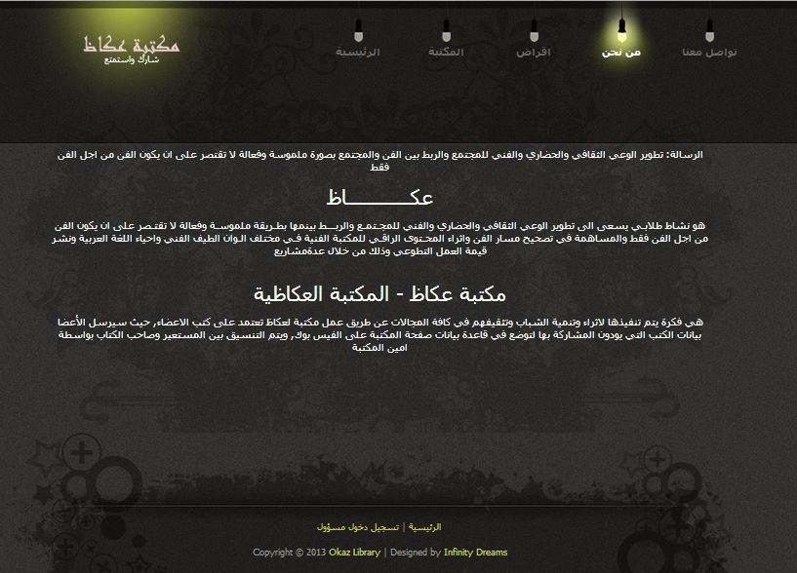
Figure 6 : about us page

Contact us
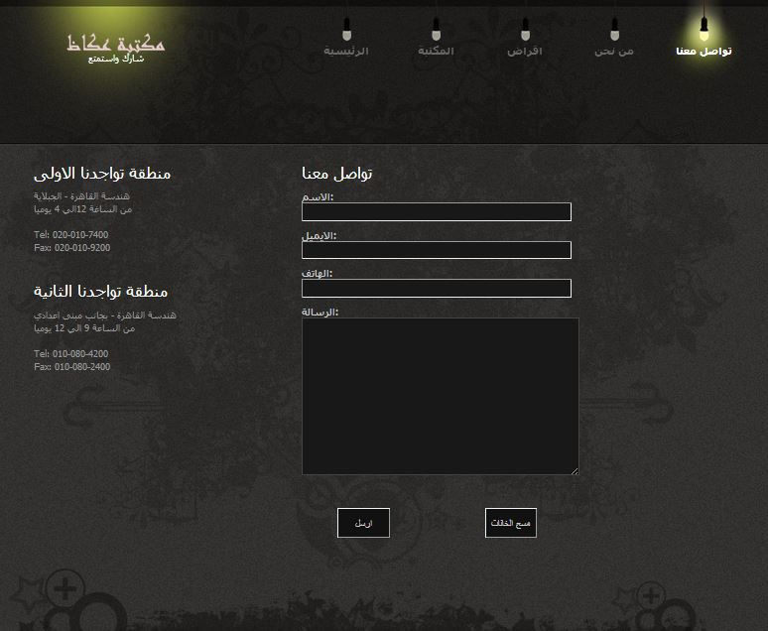
Figure 7: contact us page

Log in (Admins & Managers)
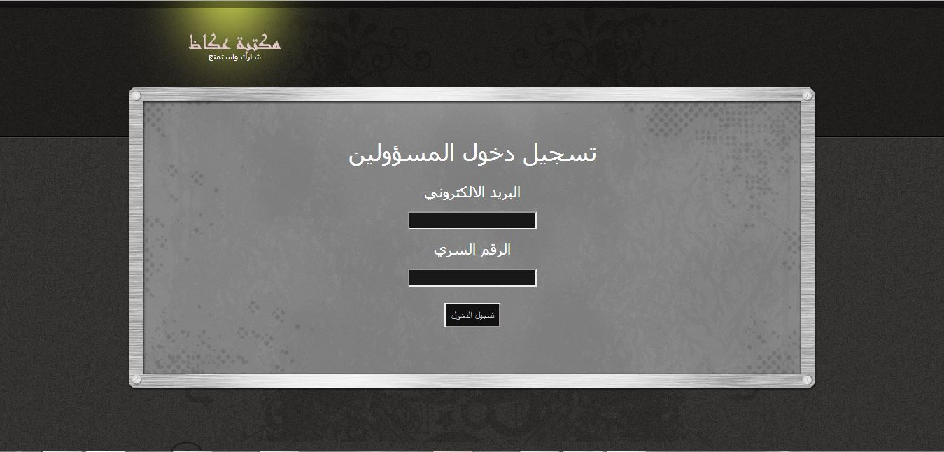
Figure 8: login

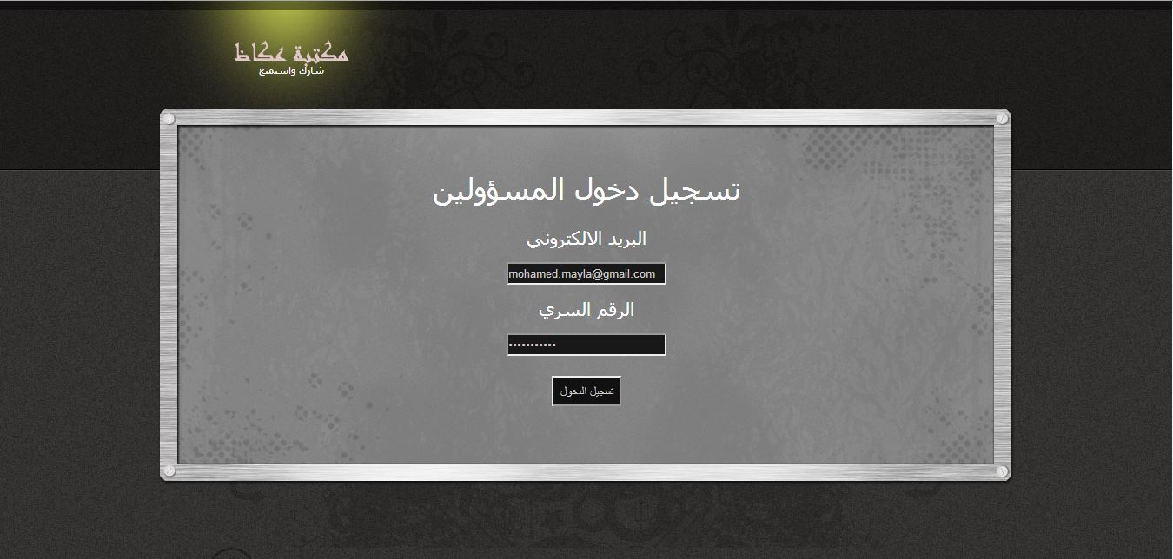
Figure 9: login data entered

Manage page
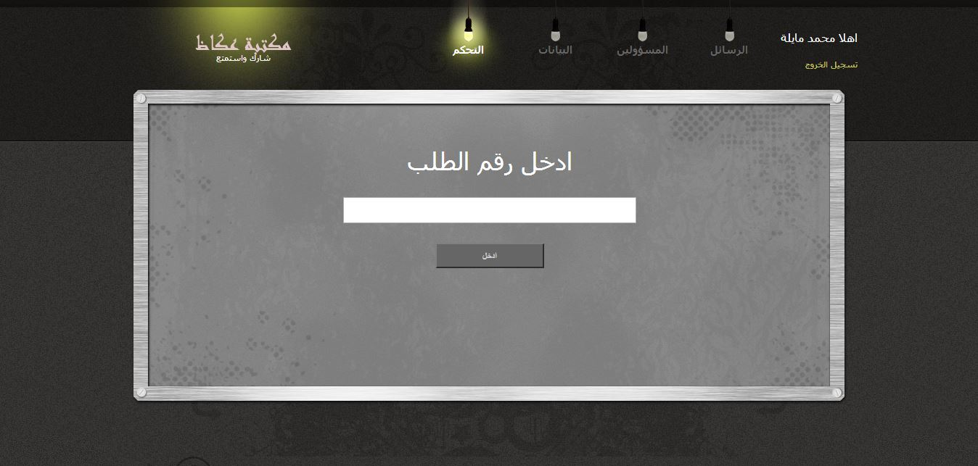
Figure 10: manage

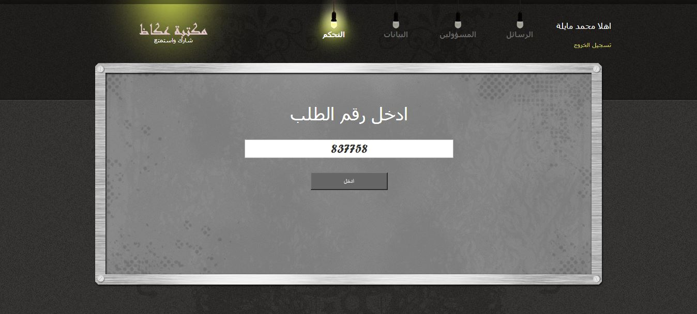
Figure 11: manage data entered

Information page
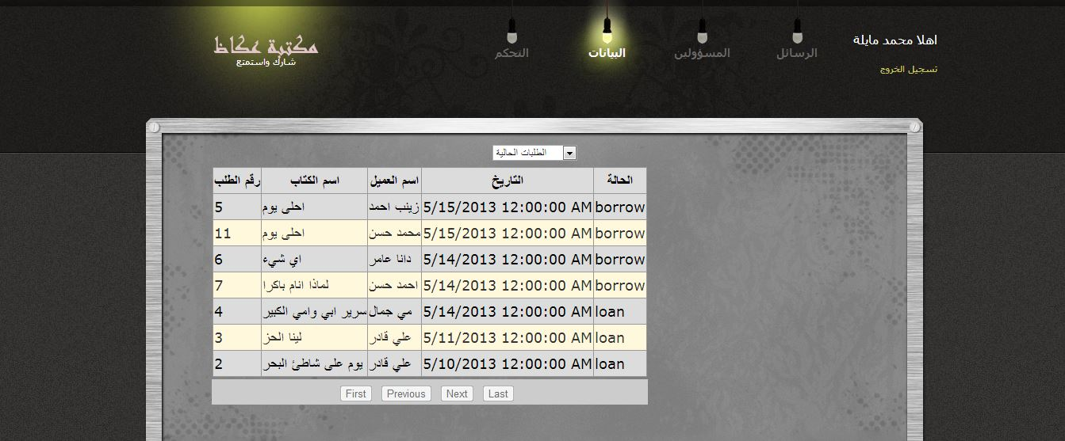
Figure 12: information page - current request

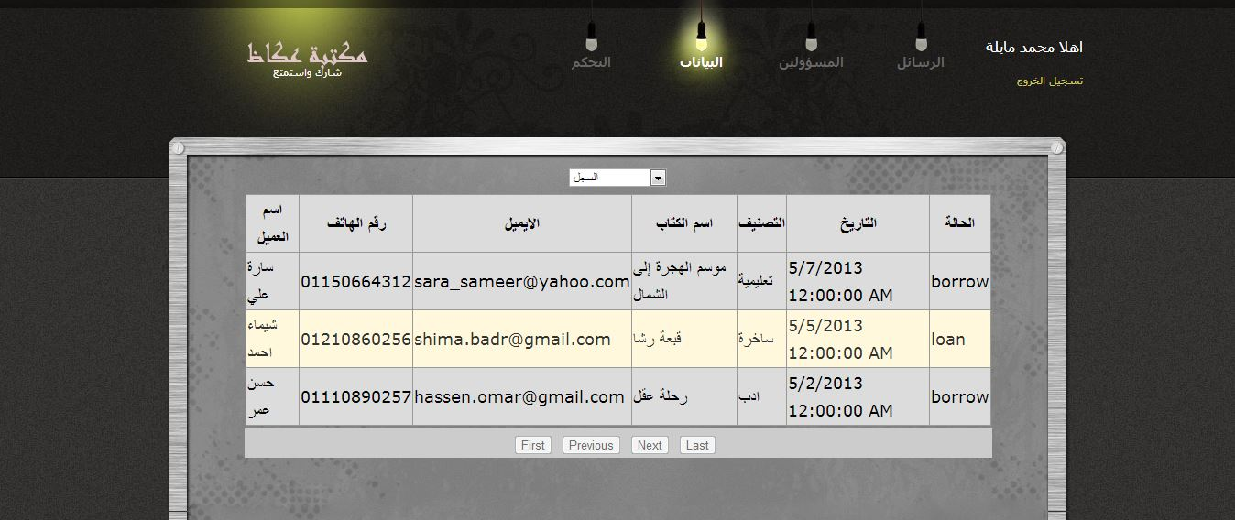
Figure 13: information page - history
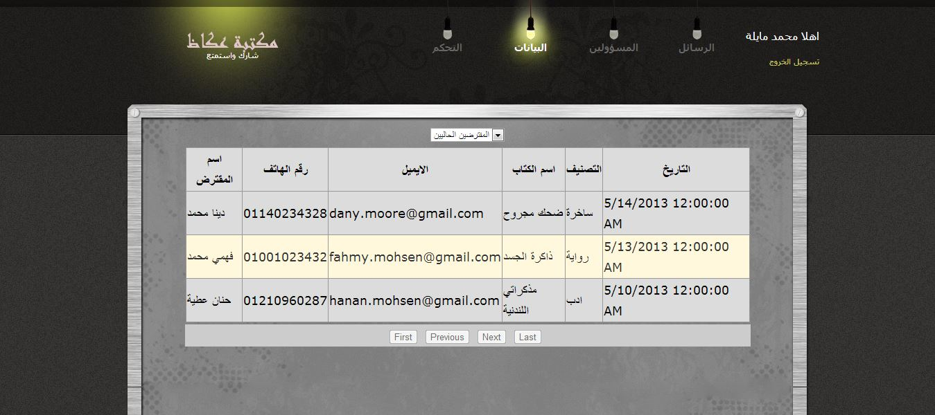
Figure 14: information page - current borrower

Admin lists
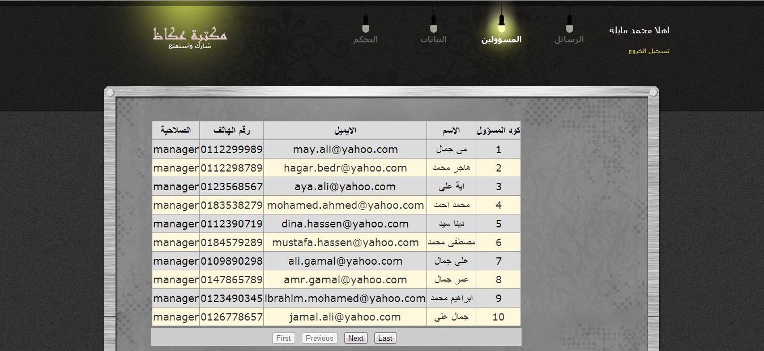
Figure 15: Admin list - manager version

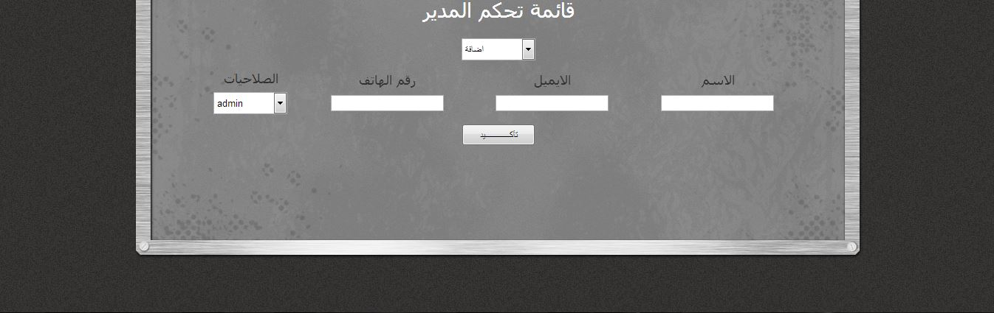
Figure 16: Admin list - admin version

Message page
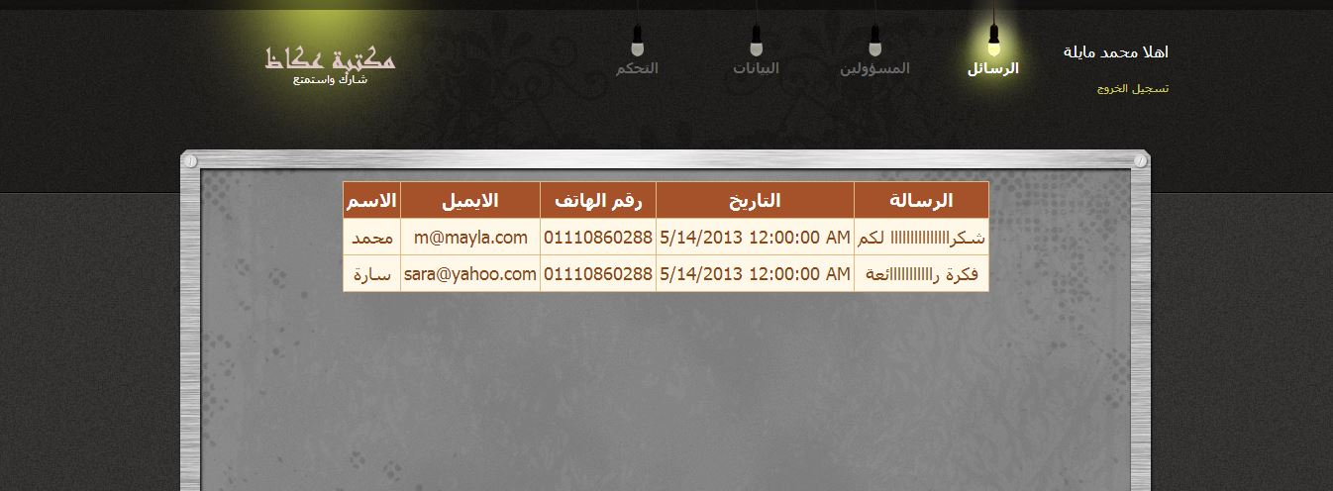
Figure 17: Message page

Class Diagrams

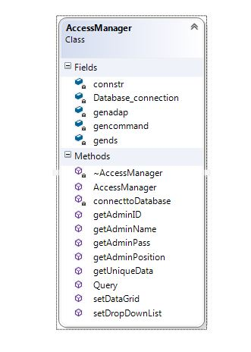
CD1
Figure 18

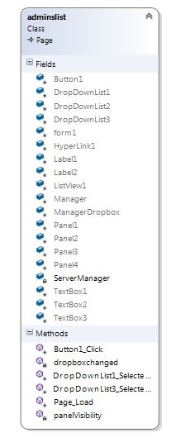
CD2
Figure 19

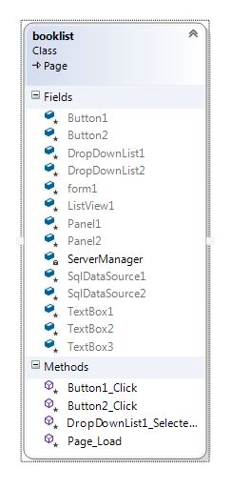
CD3
Figure 20

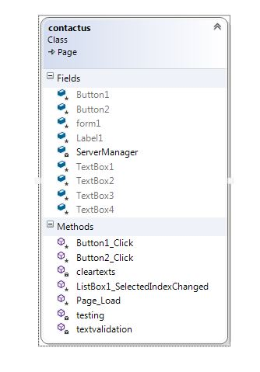
CD4
Figure 21

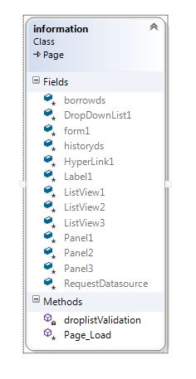
CD5
Figure 22

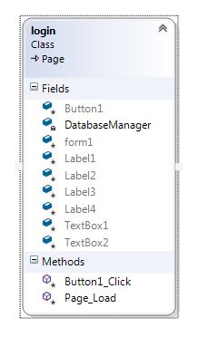
CD6
Figure 23

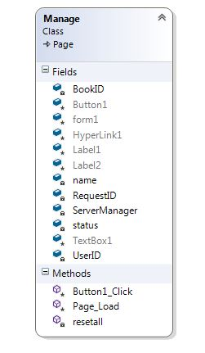
CD7
Figure 24

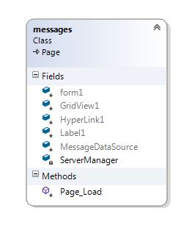
CD8

Figure 25 – CD8

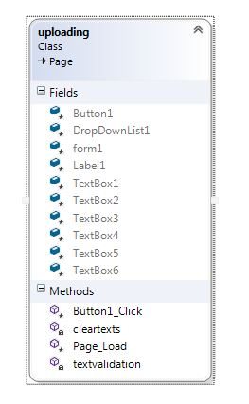
CD9

Figure 26 – CD9

Interaction Diagrams

SD1
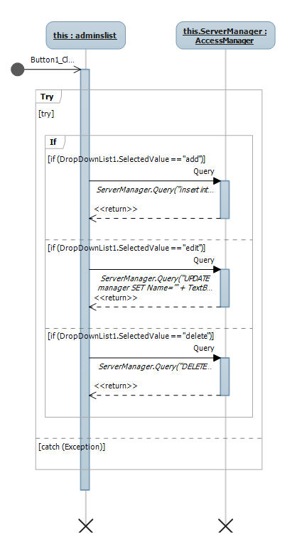
Figure 27– SD1

SD2
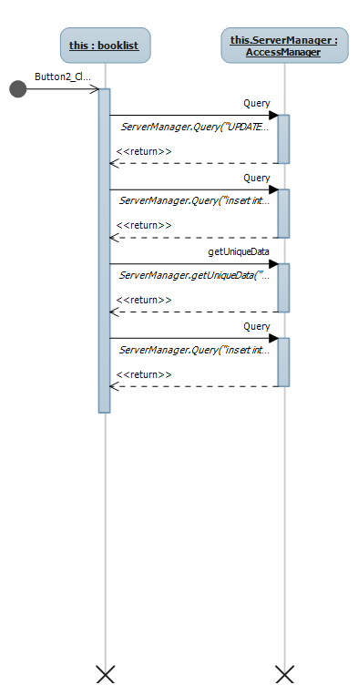
Figure 28– SD2

SD3
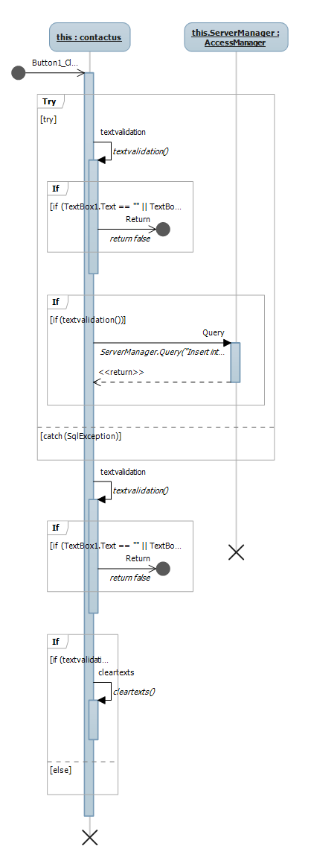
Figure 29– SD3

SD4
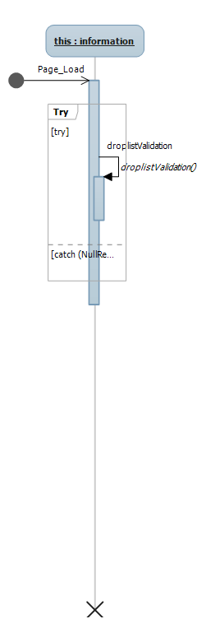
Figure 30– SD4

SD5
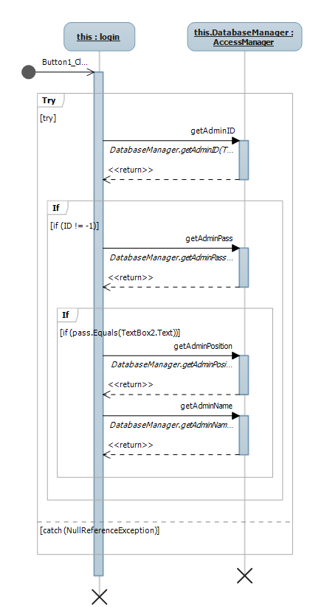
Figure 31– SD5

SD6
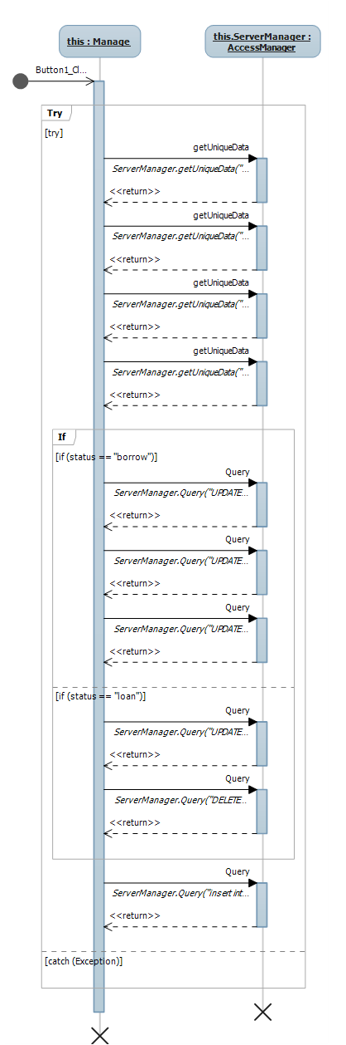
Figure 32– SD6

SD7
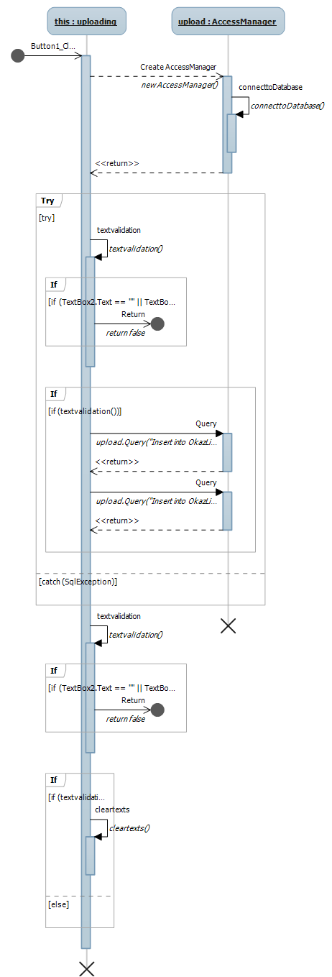
Figure 33– SD7

Data Models
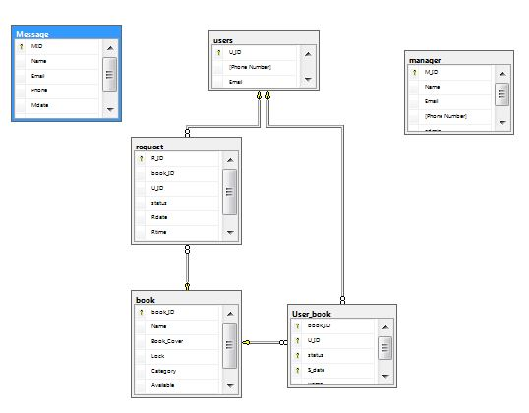
Figure 34– database model

System Deployment

“Device”
Application server

“Device”
Database server

“Device”
Personal computer

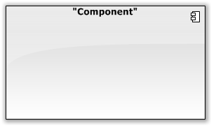

Web browser

Okaz library web application
Okaz library database server

Figure 35– system deployment

Traceability to Requirements

 | CD_1 |  | CD_2 |  | CD_3 |  | CD_4 |  | CD_5 |  | CD_6 |  | CD_7 |  | CD_8 |  | CD_9 |  | SD_1 |  | SD_2 |  | SD_3 |  | SD_4 |  | SD_5 |  | SD_6 |  | SD_7
US01 |  |  |  |  |  |  |  |  |  |  |  |  |  |  |  |  |  |  |  |  |  |  |  |  |  |  |  | 
US02 |  |  |  |  |  |  |  |  |  |  |  |  |  |  |  | 
US03 |  |  |  |  |  |  |  |  |  |  |  |  |  |  |  |  |  |  |  |  |  |  |  | 
US04 |  |  |  |  |  |  |  |  |  |  |  |  |  |  |  |  |  |  |  |  |  |  |  |  |  |  |  | 
US05 |  |  |  |  |  |  |  |  |  |  |  |  |  |  |  |  |  |  |  |  |  |  |  |  |  |  |  |  |  | 
US06 |  |  |  |  |  |  |  |  |  |  |  |  |  |  |  |  |  | 
US07 |  |  |  |  |  |  |  |  |  |  |  |  |  |  |  |  |  |  |  |  |  |  |  |  |  | 
US08 |  |  |  |  |  |  |  |  |  |  |  |  |  |  |  |  |  |  |  |  |  |  |  | 
Table 36 – traceability to requirements

